IC/FC Product Access to Users
1, Go to top left 9 dots icon click on that as shown below
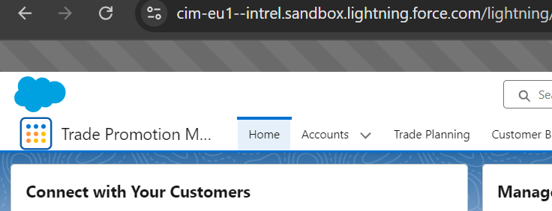

2, Click on it and Search for “Products” as shown below now click on Products
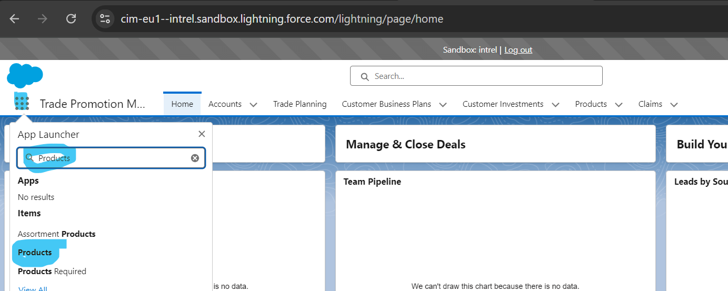

3, Now you will be redirected to Products page change “Recently Viewed” to “All products”.
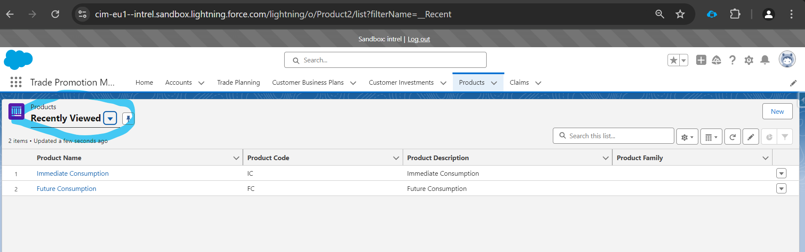
4, as shown below after
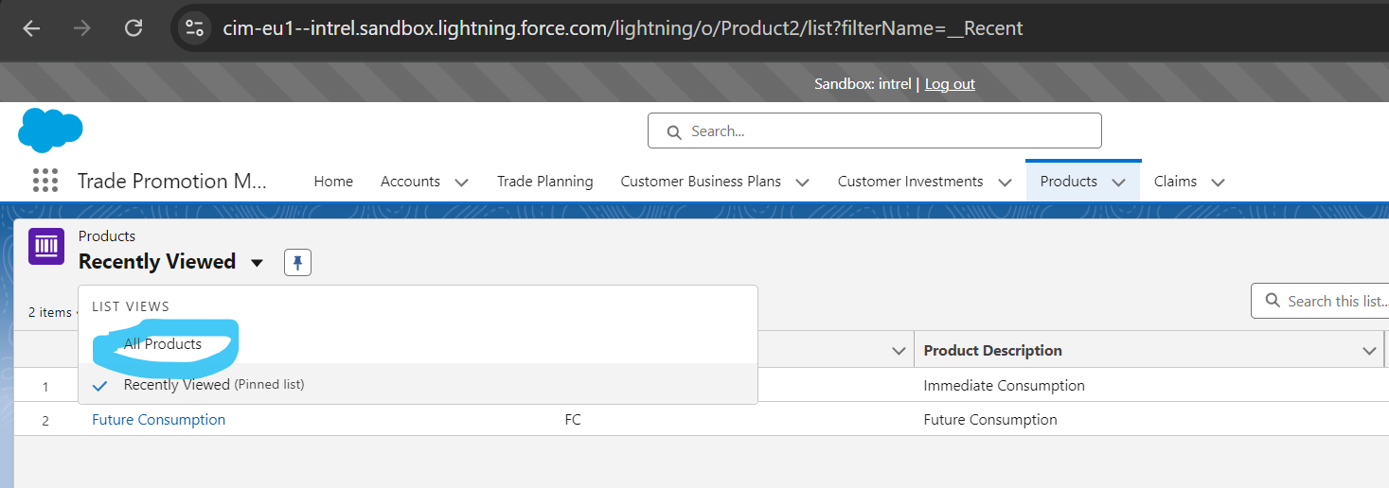
5, After this click on “All Products” left Side search for “Immediate Consumption” then open it by clicking on it
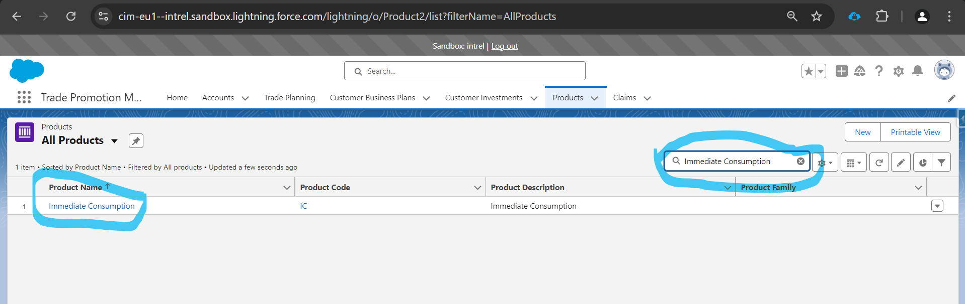
6.1, Below shown Page will open click on “Related ”
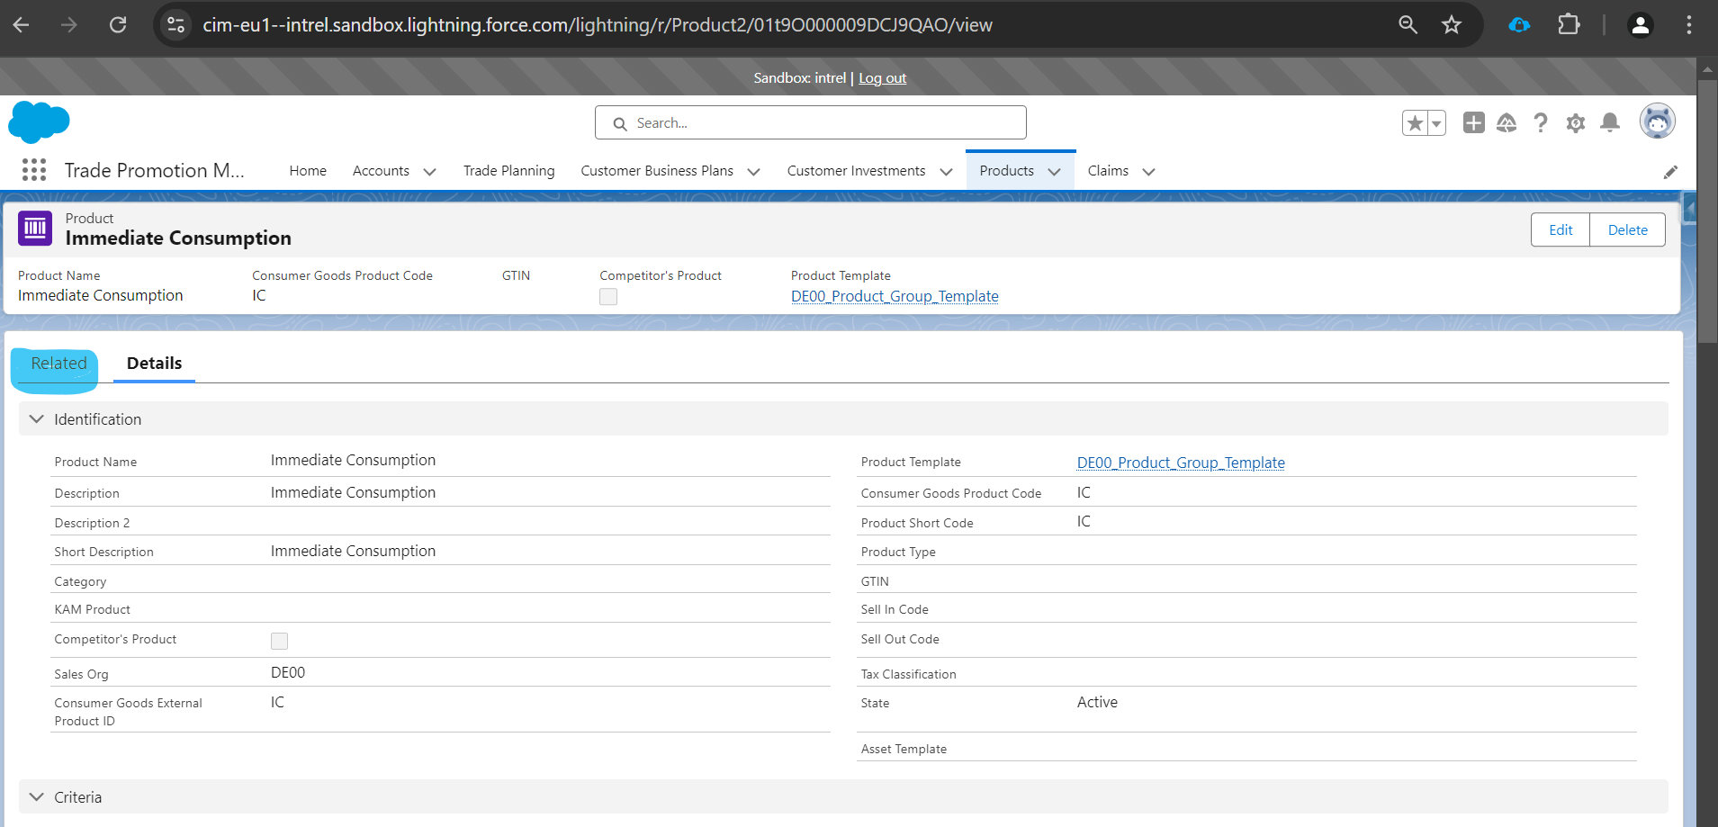
6.2, after clicking scroll down till “Product Managers” click on “New”.
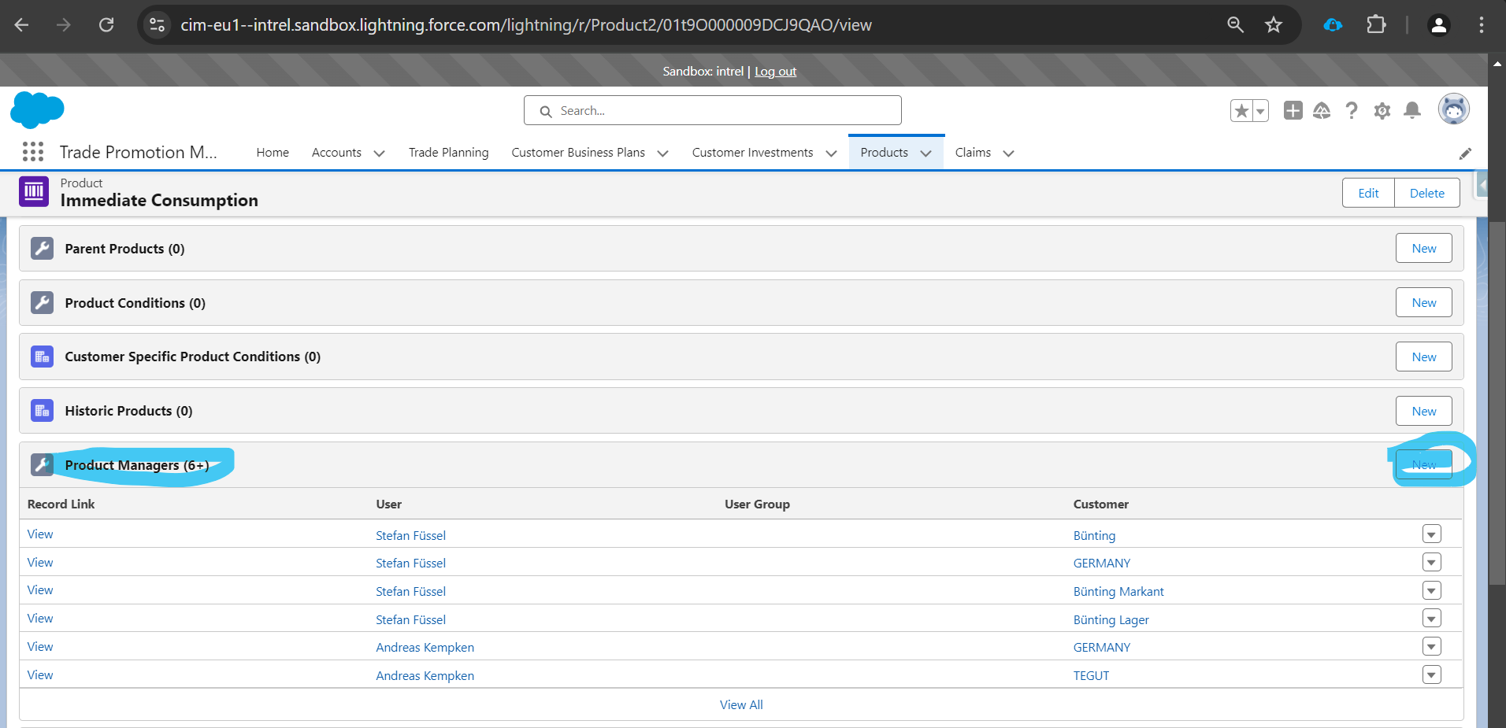
6.3, Click on “User” Record type then click on “Next” as shown below
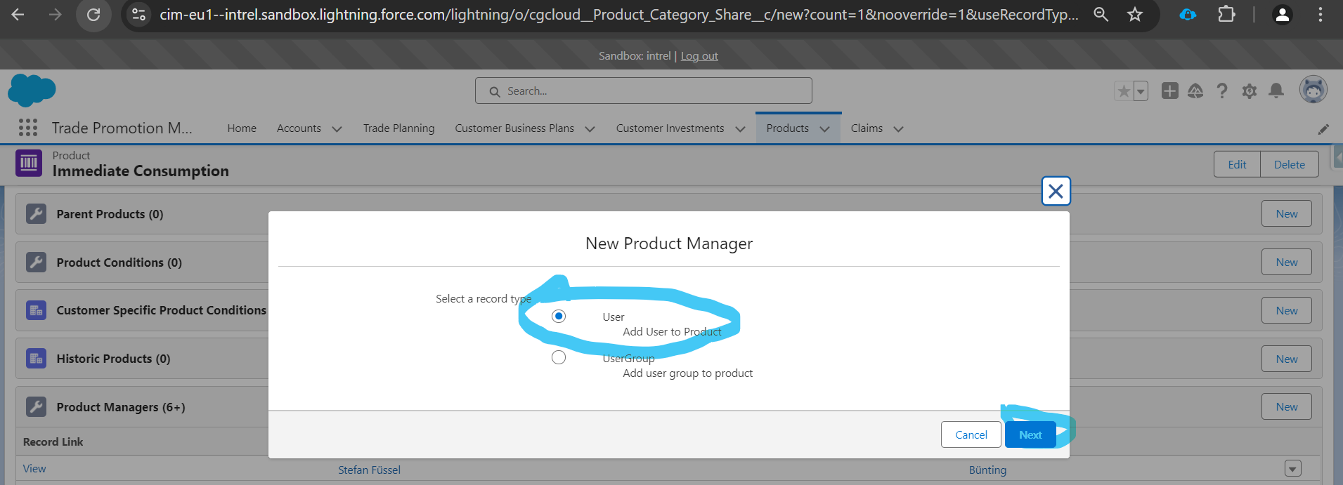

6.4, Now fill all the fields
Product - “Immediate consumption ” leave same
Access “Read/Write”
User - Name of your desired your whom you want to give access”
Customer - Which Account you want to give access for example “Amazon”, if you are leaving blank it will give access to all the accounts
Active – Active
Valid From – Start Date of access it could be today of past date
Valid Thru – Future Date of access when you want to end the access

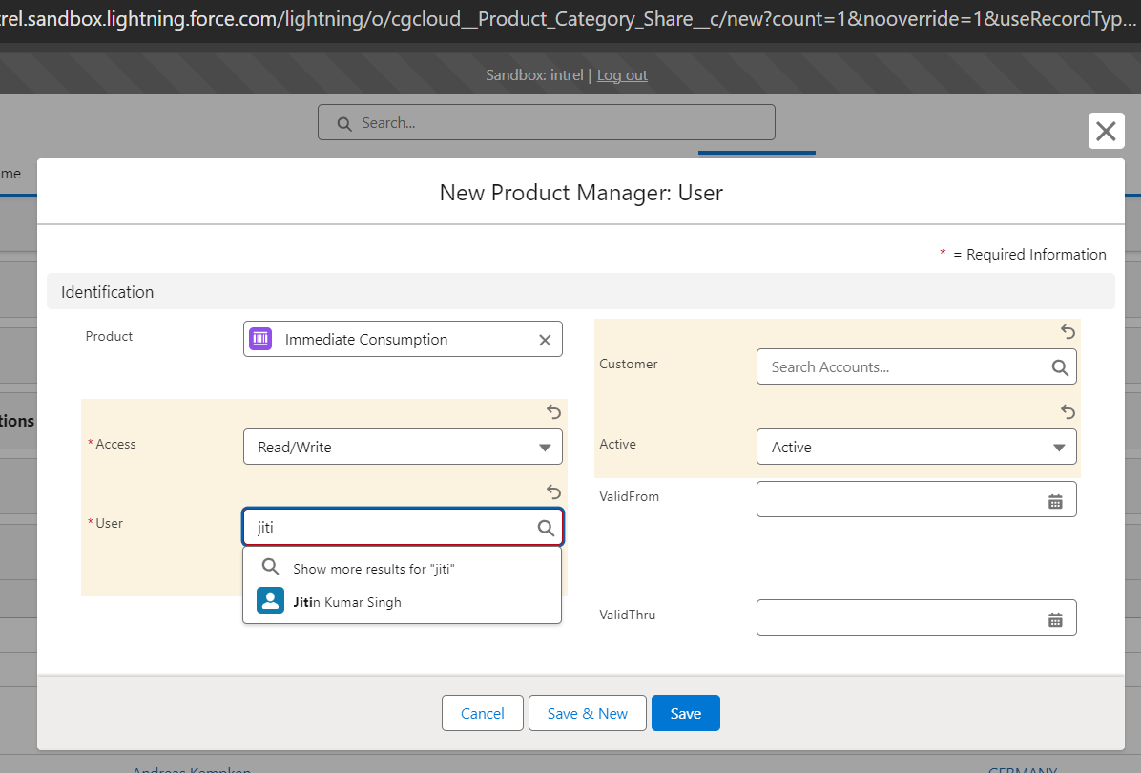

6.5 After Giving all details Hit Save and you have successfully given access for Immediate products.

7.1, Note what ever steps we have done for “Immediate Consumption” Product access giving in 6.1 to 6.5 Steps, we have to do same for “Future Consumption”

search for “Future Consumption” then open it by clicking on it.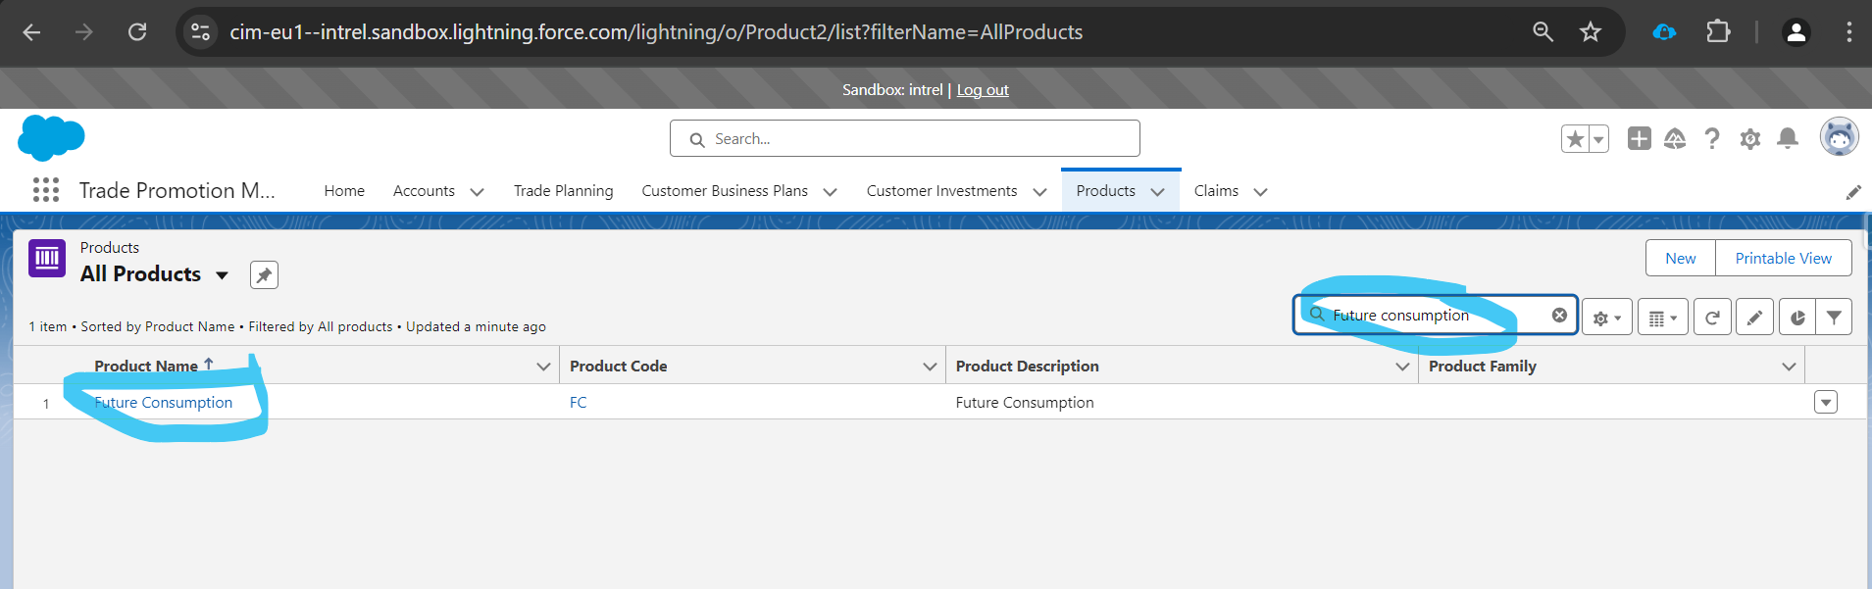

7.2 Then same open it go to “related” and scroll down search for “Product managers” on left side click on “New” then select for “User” Record type then click on “Next”
Fill the fields
Product - “Future consumption ” leave same
Access “Read/Write”
User - Name of your desired your whom you want to give access”
Customer - Which Account you want to give access for example “Amazon”, if you are leaving blank it will give access to all the accounts
Active – Active
Valid From – Start Date of access it could be today of past date
Valid Thru – Future Date of access when you want to end the access

In below image

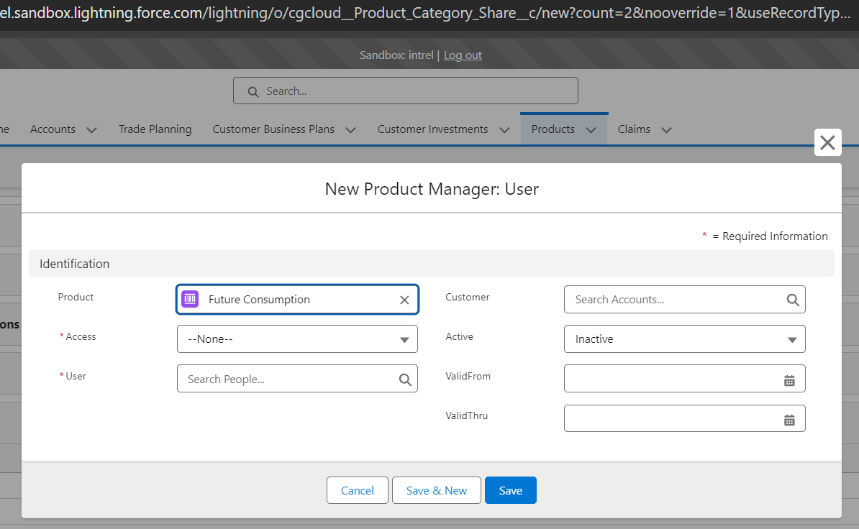

Then hit save, Hit Save and you have successfully given access for Future Products

